Meetings in Agile
Agile methodology emphasizes collaboration, transparency, and continuous improvement. To support these principles, Agile frameworks such as Scrum define a set of structured meetings, also known as ceremonies. These meetings help teams plan work efficiently, track progress regularly, and continuously improve their processes. This document explains three essential Agile meetings: Daily Standup Meeting, Sprint Planning Meeting, and Retrospective Meeting.
1. Daily Standup Meeting
The Daily Standup Meeting, also known as the Daily Scrum, is a short, time-boxed meeting conducted every working day. It usually lasts for about 15 minutes and is attended by the entire development team along with the Scrum Master. The meeting is often conducted standing up to encourage brevity and focus.
The main objective of the Daily Standup is to synchronize team activities and ensure everyone is aligned with the sprint goals. It helps team members stay informed about what others are working on and allows early identification of obstacles.
During the meeting, each team member typically answers three questions:
- What did I complete yesterday?
- What will I work on today?
- Are there any blockers or challenges preventing progress?
The Daily Standup promotes transparency and accountability within the team. It improves communication, reduces misunderstandings, and helps the Scrum Master quickly address impediments. However, problem-solving discussions should be avoided during the standup. Any detailed discussion should be taken offline after the meeting.
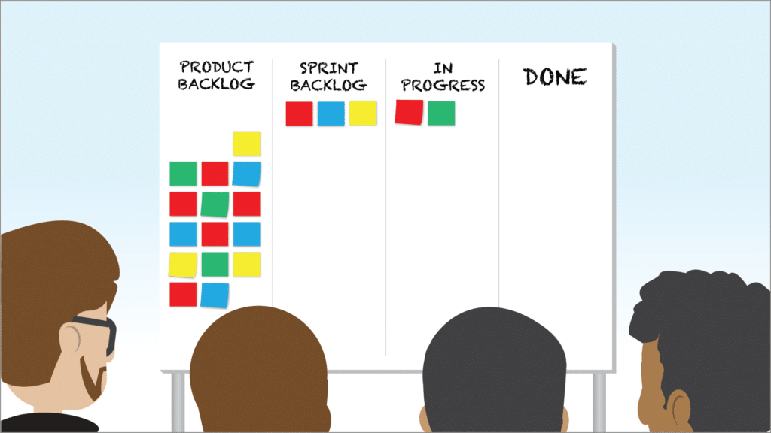
--------------------------------------------------
2. Sprint Planning Meeting
Sprint Planning Meeting is conducted at the beginning of each sprint. This meeting involves the Product Owner, Scrum Master, and the Development Team. The duration of the meeting depends on the sprint length. For a two-week sprint, the planning meeting usually lasts around two hours.
The purpose of Sprint Planning is to define what work will be accomplished during the sprint and how that work will be completed. The Product Owner presents the prioritized product backlog, and the team selects user stories that can realistically be completed within the sprint.
Key activities during Sprint Planning include:
- Reviewing and clarifying backlog items
- Defining the sprint goal
- Breaking user stories into smaller tasks
- Estimating effort using story points or hours
- Assigning responsibilities
Sprint Planning ensures that all team members have a shared understanding of sprint objectives. It improves predictability, enhances coordination, and encourages collective ownership of work. Proper backlog refinement before planning helps make the meeting more effective.
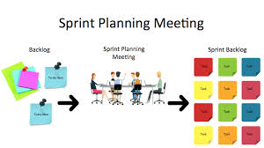
--------------------------------------------------
3. Retrospective Meeting
The Retrospective Meeting is held at the end of a sprint, after the sprint review. This meeting focuses on evaluating the team’s processes and identifying areas for improvement. It is a key component of continuous improvement in Agile.
The goal of the retrospective is to reflect on what went well, what didn’t go well, and what actions can be taken to improve future sprints. Common discussion points include team collaboration, tools, communication, and workflow.
Typical retrospective questions include:
- What went well during this sprint?
- What challenges did we face?
- What can we improve in the next sprint?
- What action items should we implement?
Retrospectives promote a culture of openness, learning, and trust. They help improve team morale and productivity by addressing issues early. It is important to create a blame-free environment where team members feel safe sharing honest feedback.

--------------------------------------------------
Conclusion
Agile meetings play a crucial role in ensuring project success. The Daily Standup keeps the team aligned on daily tasks, Sprint Planning provides clarity and direction for each sprint, and the Retrospective fosters continuous improvement. When conducted effectively, these meetings enhance collaboration, efficiency, and adaptability, making Agile teams more responsive to change and better equipped to deliver high-quality software.

